Day 3 - Daily Exercises – SQL Server
Date: 30-12-2025 → Day 3 – Subqueries, Set Operators & CTEs
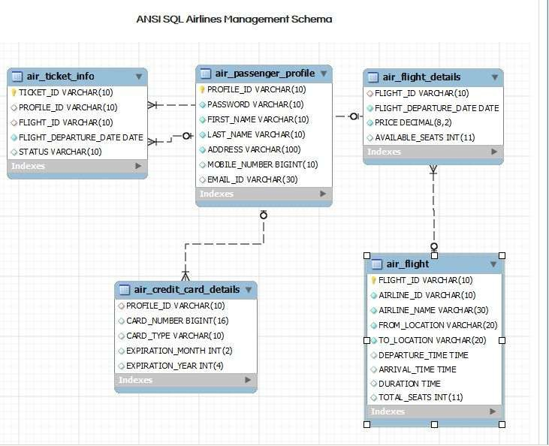
- Write a query to display the average monthly ticket cost for each flight in ABC Airlines. The query should display the Flight_Id, From_location, To_Location, Month Name as “Month_Name” and average price as “Average_Price”. Display the records sorted in ascending order based on flight id and then by Month Name.
- Write a query to display the customer(s) who has/have booked least number of tickets in ABC Airlines. The Query should display profile_id, customer’s first_name, Address and Number of tickets booked as “No_of_Tickets”. Display the records sorted in ascending order based on customer's first name.
- Write a query to display the number of flight services between locations in a month. The Query should display From_Location, To_Location, Month as “Month_Name” and number of flight services as “No_of_Services”. Hint: The Number of Services can be calculated from the number of scheduled departure dates of a flight. The records should be displayed in ascending order based on From_Location and then by To_Location and then by month name.
- Write a query to display the customer(s) who has/have booked maximum number of tickets in ABC Airlines. The Query should display profile_id, customer’s first_name, Address and Number of tickets booked as “No_of_Tickets”. Display the records in ascending order based on customer's first name.
- Write a query to display the number of tickets booked from Chennai to Hyderabad. The Query should display passenger profile_id,first_name,last_name, Flight_Id , Departure_Date and number of tickets booked as “No_of_Tickets”. Display the records sorted in ascending order based on profile id and then by flight id and then by departure date.
- Write a query to display flight id,from location, to location and ticket price of flights whose departure is in the month of april.
- Write a query to display the average cost of the tickets in each flight on all scheduled dates. The query should display flight_id, from_location, to_location and Average price as “Price”. Display the records sorted in ascending order based on flight id and then by from_location and then by to_location.

- Write a query to display the customers who have booked tickets from Chennai to Hyderabad. The query should display profile_id, customer_name (combine first_name & last_name with comma in b/w), address of the customer. Give an alias to the name as customer_name. Hint: Query should fetch unique customers irrespective of multiple tickets booked. Display the records sorted in ascending order based on profile id.
- Write a query to display profile id of the passenger(s) who has/have booked maximum number of tickets. In case of multiple records, display the records sorted in ascending order based on profile id.
- Write a query to display the total number of tickets as “No_of_Tickets” booked in each flight in ABC Airlines. The Query should display the flight_id, from_location, to_location and the number of tickets. Display only the flights in which atleast 1 ticket is booked. Display the records sorted in ascending order based on flight id.

